Task # 01 (Default Constructor Initialization)
- Create a class named Student with instance variables name and Roll Number.
- Create a default constructor that initializes the name to "Unknown" and Roll Number to 0.
- Create a student object without passing any arguments and print its details.

CODE:  class Student {  String name;  int rollNumber;  public Student() {  name = "Unknown";  rollNumber = 0;  } public static void main(String[] args) {  Student student = new Student(); | System.out.println("Student Name : " + student.name);  System.out.println("Student Roll-Number : " + student.rollNumber);  }  }  OUTPUT:

Task # 02 (Parameterized Constructor Initialization)
- Add a parameterized constructor to the student class that takes name and roll Number as parameters and initializes the instance variables.
- Create a student object by passing values to the parameterized constructor and print its details.
CODE:  class Student {  String name;  int rollNumber;  public Student(String name, int rollNumber) {  this.name = name;  this.rollNumber = rollNumber;  } public static void main(String[] args) { | Student student = new Student("Muneeb", 27855);  System.out.println("Student Name : " + student.name);  System.out.println("Student Roll-Number : " + student.rollNumber);  }  }    OUTPUT:

Task # 03 (Method-Based Initialization)
- Add a method setName and setRollNumber to the Student class to set the values of the instance variables.
- Create a Student object using the default constructor.
- Use the setName and setRollNumber methods to initialize the object's values and print the details.
CODE:  class Student {  String name;  int rollNumber;  void setName(String name) {  this.name = name;  }  void setRollNumber(int rollNumber) {  this.rollNumber = rollNumber;  } | public static void main(String[] args) {  Student student = new Student();  student.setName("Muneeb Mughal");  student.setRollNumber(27855);  System.out.println(student.name);  System.out.println(student.rollNumber);  }  }    OUTPUT:

Task # 04 (Combining Constructors and Methods)
- Create a parameterized constructor that initializes only the name and a setRollNumber method to initialize the rollNumber.
- Create a Student object using the parameterized constructor and then use the setRollNumber method to complete the initialization.
- Print the object's details.
CODE:  class Student {  String name;  int rollNumber;  Student(String name) {  this.name = name;  }  void setRollNumber(int rollNumber) {  this.rollNumber = rollNumber;  }  public static void main(String[] args) {  Student student = new Student("Muneeb Mughal");  student.setRollNumber(27855);  System.out.println(student.name);  System.out.println(student.rollNumber);  }  } |   OUTPUT:

Task # 04 (Understanding Reference Variables)
- Create two Student objects, student1 and student2.
- Assign the reference of student1 to student2.
- Modify a property of student1.
- Print the values of both student1 and student2 to observe the effect of reference assignment..
CODE:  class Student {  String name;  int rollNumber;  Student(String name, int rollNumber) {  this.name = name;  this.rollNumber = rollNumber;  }  void displayInfo() {  System.out.println("Name : " + this.name);  System.out.println("Roll Number : " + this.rollNumber + "\n");  }  public static void main(String[] args) {  Student student1 = new Student("Muneeb Mughal", 27855);  Student student2 = new Student("Umar Feroz", 28255);  System.out.println("Before assigning reference of student 1 to student 2");  System.out.println("Student 1 :");  student1.displayInfo() | System.out.println("Student 2 :");  student2.displayInfo();  student1 = student2;  System.out.println("After assigning reference of student 1 to student 2");  System.out.println("Student 1 :");  student1.displayInfo();  System.out.println("Student 2 :");  student2.displayInfo();  }  }  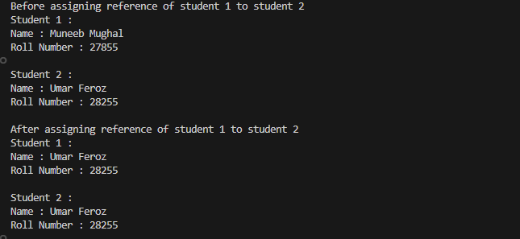  OUTPUT:

